A picture containing clipart

Description generated with very high confidence

Azure 103 Module 4

Hands On - 5

Azure Certification Training

[**support@intellipaat.com**](mailto:support@intellipaat.com)

**+91-7022374614**

**US: 1-800-216-8930(Toll Free)**

**Azure 103 Module 4 , Hands On – 5**

**Add Routes**

**Step 1:** Open the VM in Azure portal.

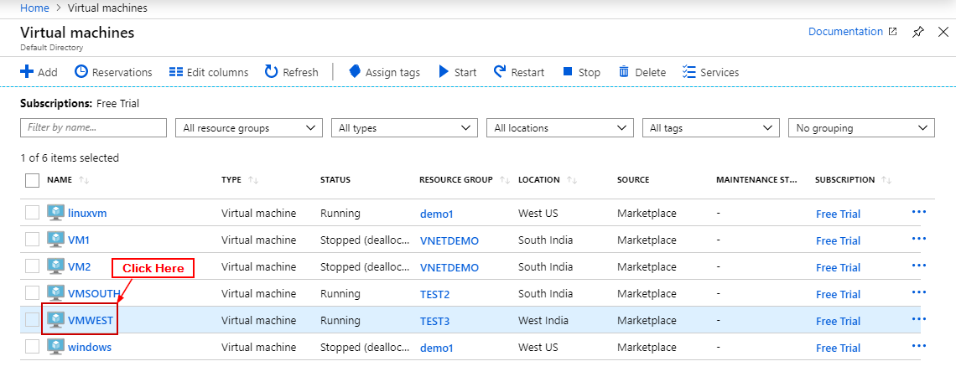

**Step 2:** Click on Networking.

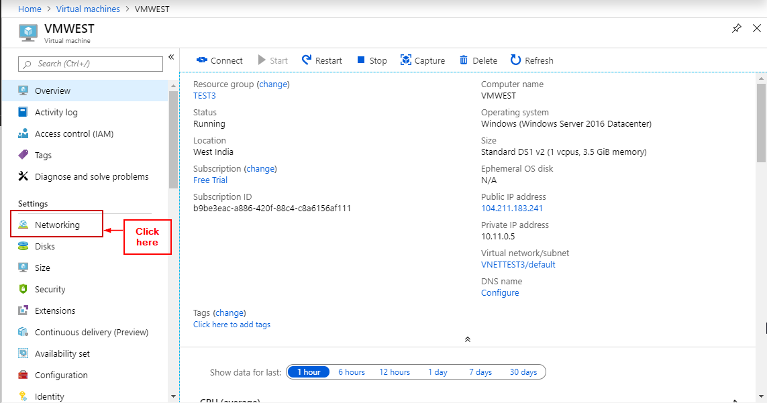

**Step 3:** Click on Network Interface

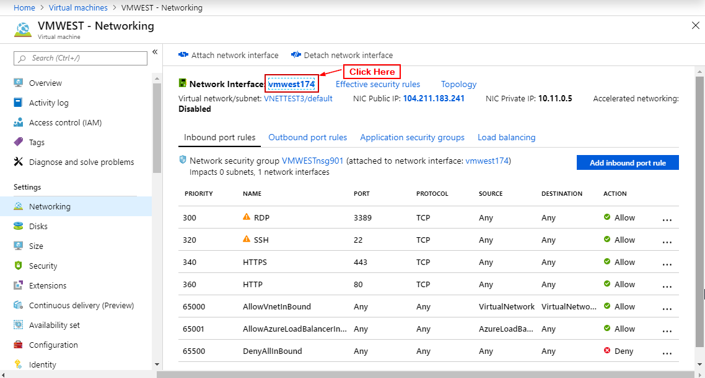

**Step 4:** Click on IP configurations.

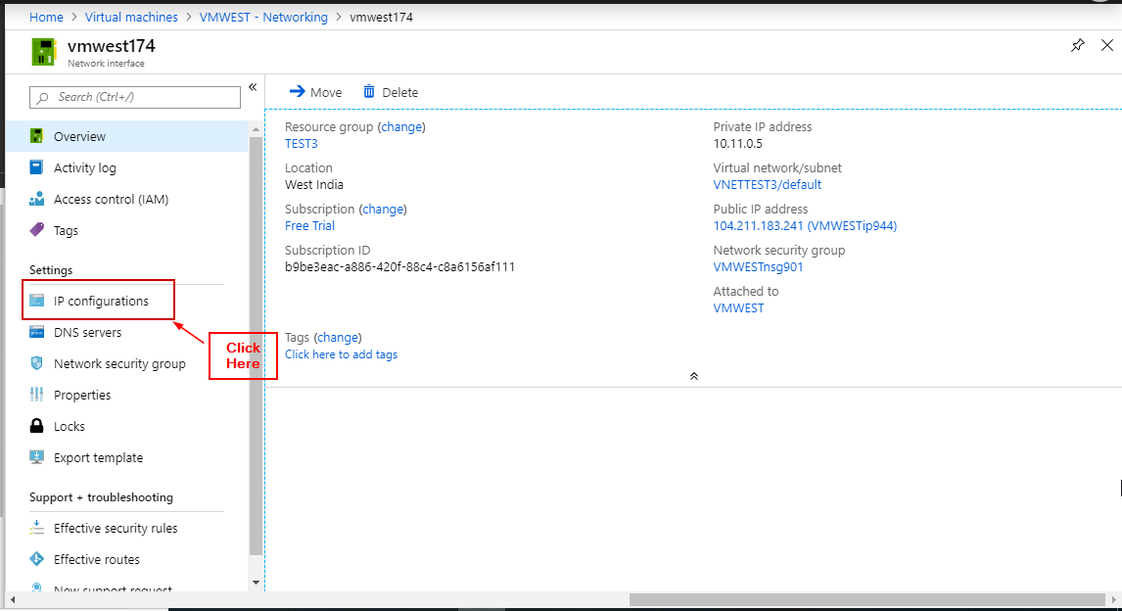

**Step 5:** Click on IP Configuration that was generated by default.

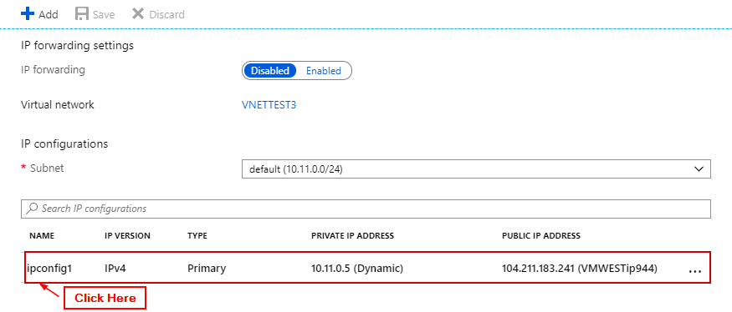

**Step 6:** Enter the details and click on save.

